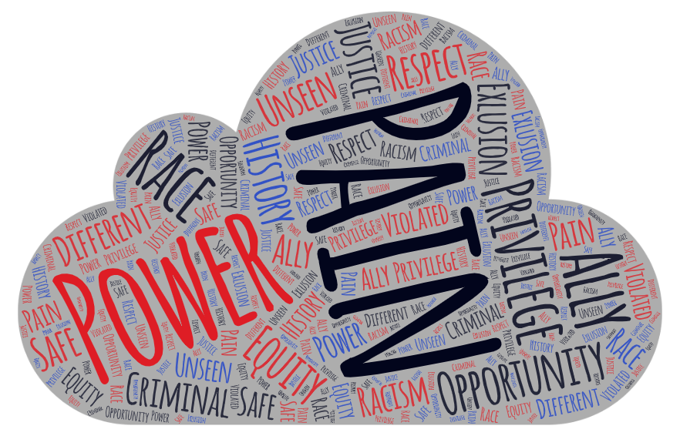
I’ve watched numerous documentaries and cinematic masterpieces focusing on racial injustice and police brutality over the past few months. While I was already painfully aware of the reality of our corrupt policing system and white privilege that is today’s country, these movies drove the pain and oppression that people of color face into my mind in a way that I will never be able to forget. The words presented in the cloud above are words that stuck with me throughout the months and always resonated with me when describing the disgust that is racial injustice. I believe that people of color would resonate with these words as well and agree that it’s a heart-breaking but true representation of the way that oppression makes people feel. I wish that these issues were not a part of our present, and quite literally stayed in the past, because our country is suffering. The people are suffering. The people with the most power are the ones who can fix it, which is a sad truth considering those currently in power. These movies and documentaries bring a light to these realities which I think is important in order to draw further public attention.

